Chapter 19, Solution 52.

It is easy to find the z parameters and then transform these to h parameters and T parameters.

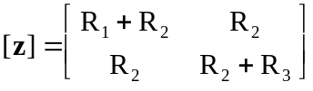

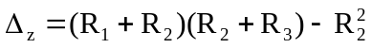
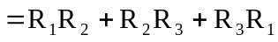

- 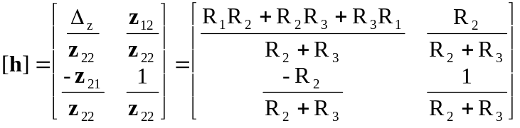

Thus,
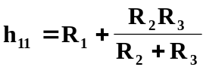, 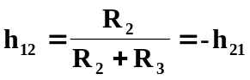, 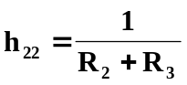
as required.

- 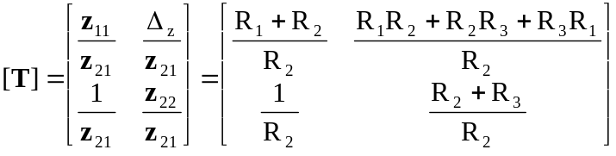

Hence,
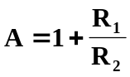, 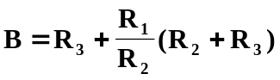, 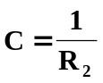, 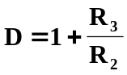
as required.

